# Table of Contents

Table of Contents i

I Laboratory Session 1

II. Distribution Pharmacy 2

2.1 Distribute 3

2.1.1 Patient Lis 3

2.1.2 Medical Prescription Part 4

2.2 Prepare Request 5

2.2.1 Stock Level 5

2.2.2 New Stock Request From 6

III. Health Center Main Medicine Store 7

3.1 Medicine 7

3.1.1 Stock 7

3.1.2 Request 9

3.1.3 Command 10

# I Laboratory Session

# II. Distribution Pharmacy

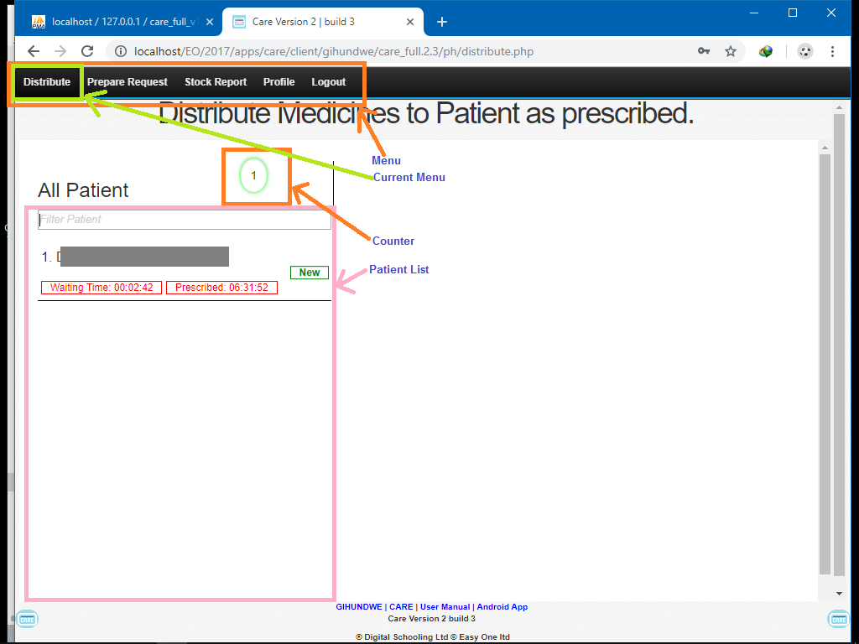

The Distribution Pharmacy has feature like

* Distribute
* Prepare Request
* Stock Report
* Profile

## 2.1 Distribute

The Distribute Page has to main part

### 2.1.1 Patient Lis

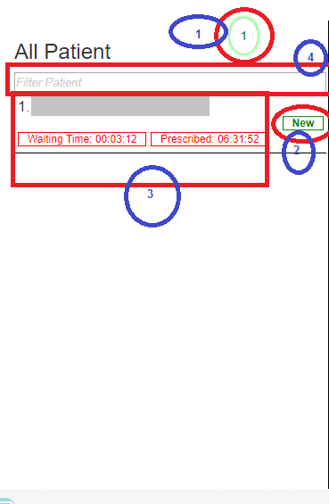

Number in blue circle are going to be described

1: Counter how many patient are in the list

2: Inform which Patient has Medicine Prescribed

3: Patient Identification by which you select one

4: Where you can apply filter to remain only with limited number of records

### 2.1.2 Medical Prescription Part

The Medical Prescription Part has different part as described

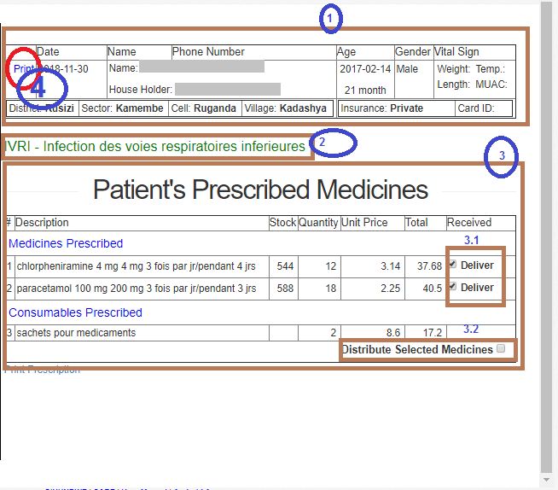

1: Patient Identification, please make sure the patient in front of you is the one you are about to deliver medicines in the computer screen

2: If possible, make sure the diagnostic provided allows you to distribute the prescribed medicine

3: List of Prescription, please make sure that everything is OK like consumable and some other medicines prescription if possible

3.1 Make sure that you check only distributed Medicines

3.2 And at last approve the distribution of all medicine to allow stock report to be generated.

4: Print the Prescription Document for CBHI Users if necessary.

## 2.2 Prepare Request

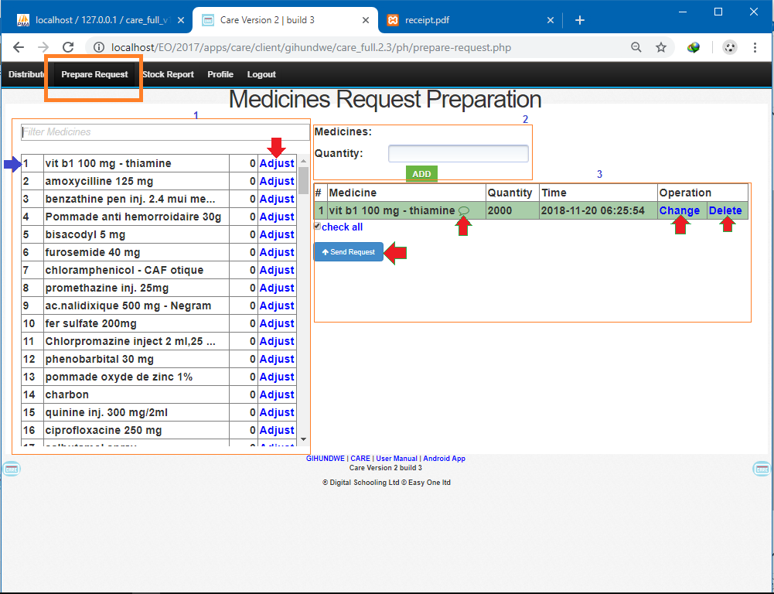

The Prepare Request Page has many information like stock level and request status. Green bordered red arrow has functionalities attached to them **Send Request**, **Review the Request** and **Delete** and from their you can check any comment sent from main stock profile by putting the mouse over a record

### 2.2.1 Stock Level

It indicated by blue Number 1

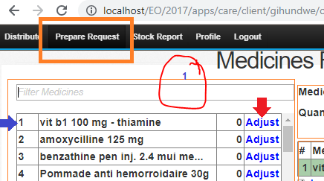

It has information

Medicine Name

Current Stock Level

And it allow two different operation

Blue Arrow:

Once you click on the Medicine row you Open the form labeled number 2 to accept requesting new stock of medicine to the health center main medicine store

Red Arrow:

Once you click on the adjust blue text, you get a box asking you the real stock status you have and after confirming your number the stock automatically get adjusted to the new value 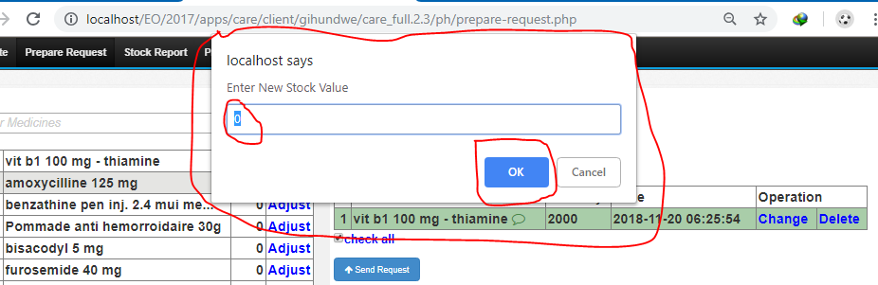

After the OK button the new stock value should appear in front of the selected medicine

### 2.2.2 New Stock Request From

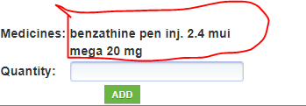

After Selecting the Medicine Name from the stock level part you provided the desired quantity and after you click add automatically the requested medicine will be added on the wish list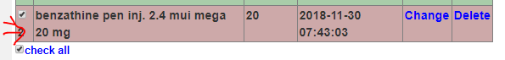

Those Records in brown color are still hidden from main medicine store until sent.

# III. Health Center Main Medicine Store

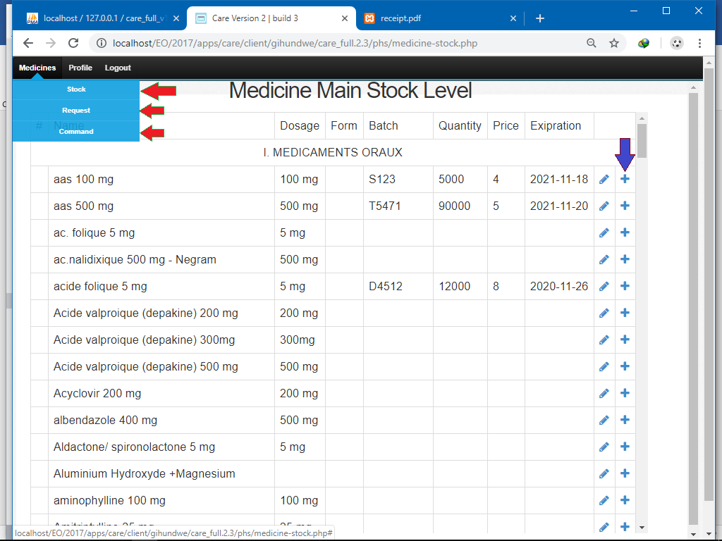

## 3.1 Medicine

Medicine Feature Has three main component to checked

1. Stock
2. Request From Distribution Pharmacy
3. Command Prepared for external Supply

### 3.1.1 Stock

The Stock Show all Medicine which can be used at the health center alongside with the expiration, batch number, available Quantity and buying price for every medicine

The Blue plus sign allows user to directly put such medicine the command wish list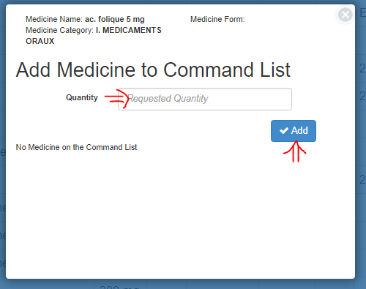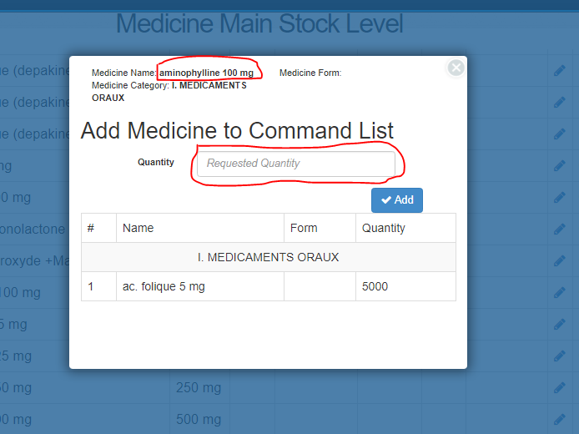

### 3.1.2 Request

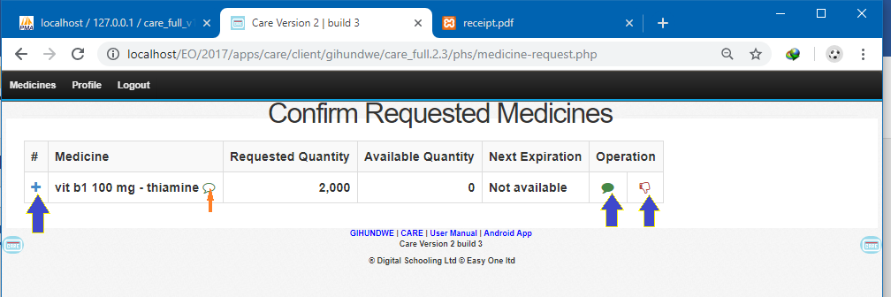

The Interface allows three different Operation

1. Adding Medicine to command wish List
2. Sending Comment to Distribution Pharmacy User
3. Approve and Deliver the requested Medicines

Adding to command wish list is the same as previous

Send Comment look like This  
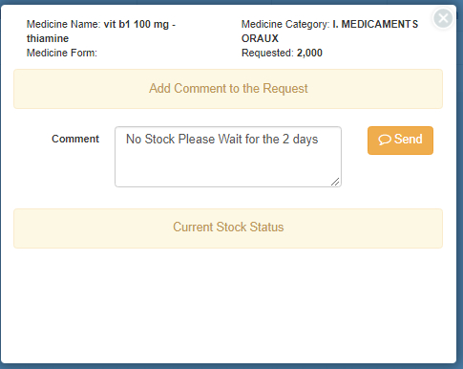

Approve and Deliver looks like this  
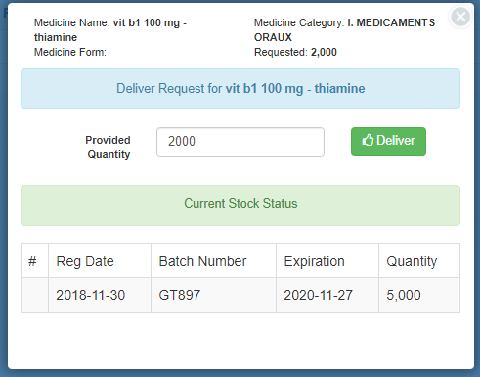

### 3.1.3 Command

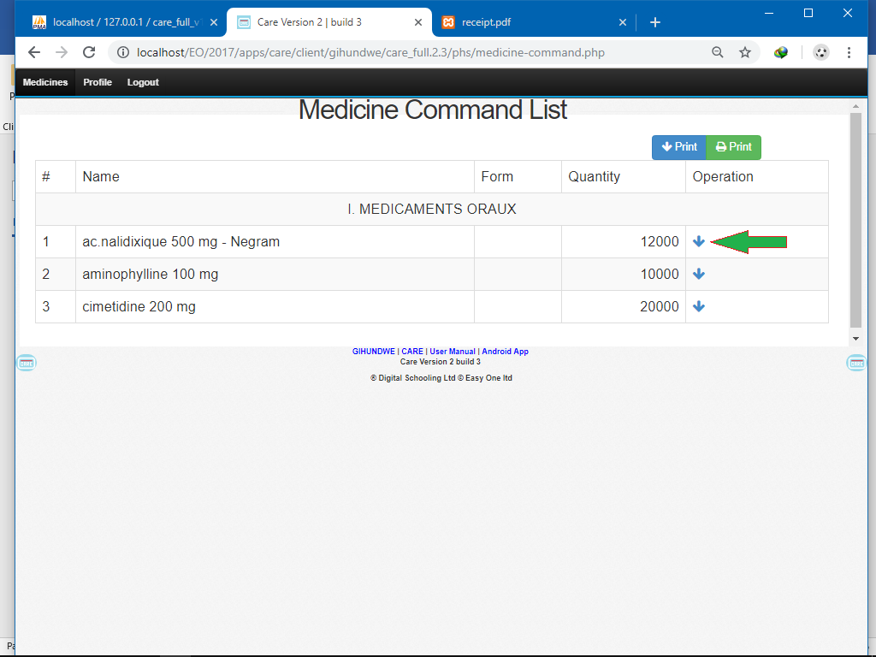

This Page allow to receive Command From External Pharmacy like District Pharmacy, or any other possible capable pharmacy to supply the health center

Fill the Form Below to receive every medicine in the stock  
